

A Case for Support
February, 2015

Little People of America, Inc., is a national non-profit organization that provides support and information to people of short stature and their families. We are the only dwarfism support organization that includes all 200+ forms of dwarfism. There are an estimated 30,000 people with dwarfism in the United States, and 651,700 in the world. No other non-profit in the world provides more resources, support and information for people with dwarfism.

Since 1957, Little People of America, Inc. (LPA) has been providing support to people with dwarfism. People with dwarfism come from all walks of life and ethnic backgrounds. More than 80 percent are born to average-size parents with no history of dwarfism in the family.

A child with dwarfism is born one per 10,000 births. LPA’s members are both individuals with dwarfism and average-height people who are parents, children, siblings, friends, family, and medical professionals. We represent all ages. We are singles, we are families, and our children are biological and adopted. We are from many ethnic origins, we are professionals and trades people. In other words, we are a community.
Founded in 1957 by actor Billy Barty, LPA is an effective, caring and needed voice on dwarfism issues. We address all aspects of dwarfism, including:
- Awareness – LPA educates the public, government, media, medical community and affected individuals and families about dwarfism.
- Education - LPA provides continuing education scholarships for its members, including scholarships for community and four-year colleges, trade schools, and graduate school.
- Medical Issues – LPA works with our highly respected Medical Advisory Board to provide the best treatment information and medical resources available. All Medical Advisory Board members donate their time during LPA conferences.
- Advocacy – LPA advocates for equal and dignified treatment of people with dwarfism in all aspects of living.
- Public Access – LPA participates in federal government hearings and private standards-setting organizations on access issues for Little People.
- Adoption Opportunities – LPA assists families who are seeking to adopt a child and children who are put up for adoption by their birth parents. Our Adoption Committee works within the United States and internationally to find healthy, loving families for children with dwarfism.
- Social Opportunities – LPA provides peer and family support, mentoring and social opportunities for the dwarfism community.
LPA volunteers provide many aspects of service, from speaking with parents of a newly diagnosed child to testifying at the United States Access Board in Washington D.C. regarding height and access issues in public places. The success of LPA is the result of many caring people working together to further a common vision of support, acceptance and tolerance of physical difference.
During 2014-15, LPA must raise $95,000 through grants and private contributions to carry out its programs and accomplish its strategic goals. The work of LPA is only made possible by people who share the vision that: 1) all people with dwarfism can be valuable, educated, contributing members of society, and 2) the general public needs to be educated about dwarfism and physical difference.

Our Mission
LPA is dedicated to improving the quality of life for people with dwarfism throughout their lives while celebrating with great pride Little People’s contribution to social diversity. LPA strives to bring solutions and global awareness to the prominent issues affecting individuals of short stature and their families.

Our Accomplishments

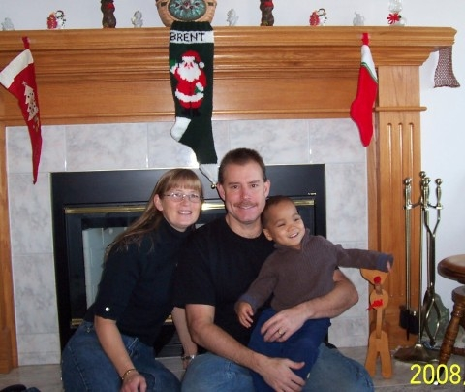

“In 2007 my husband and I made the decision to adopt a toddler, and decided we wanted to adopt a Little Person (LP). We were connected with Colleen (Gioffreda) through the Little People of America office. She introduced us to agencies hosting children all around the globe who were of short stature and waiting for a forever family. We ‘found’ our son with the help and support of our LPA family.” –Denise and Kevin Wood

Between 2006 and 2013, LPA experienced tremendous growth in our major programs and services, despite a challenging economic environment. For example:

- Our membership increased by 20%, from 5,287 to 6,409 members
- We kept in touch with our members through our “new and improved” Web site, frequent Facebook posts, a monthly e-newsletter (which boasts an average open rate of 40%, compared to just 25% for similar publications), and enhanced the quality and content of our printed LPA Today magazine while increasing its length from an average of 24 to 32 pages.
- Our membership passed an extensive by-laws revision, which resulted in a significant change in the organization’s governance structure. A detailed description of our new governance structure is provided on page 5.
- We received nearly $169,941 in donations during fiscal year 2012-13 – an increase of 300% from 2006, when we received $41,716.
- In 2006, we provided adoption grants to five families, more than doubling our adoption assistance to 12 families by 2013.
- In 2006, we provided $27,000 in scholarships, increasing this figure to $37,750 by 2013 – an increase of 40%.
- In 2013, we coordinated our fourth annual National Dwarfism Awareness Month, including daily posts on Facebook, creating and selling green Dwarfism Awareness bracelets, and continued growth in the number of states officially recognizing October as National Dwarfism Awareness Month
- Our Medical Advisory Board (MAB) provided medical consultations to 400 members at the 2013 National Conference, in addition to consultations provided at select regional conferences

Our Strategic Direction

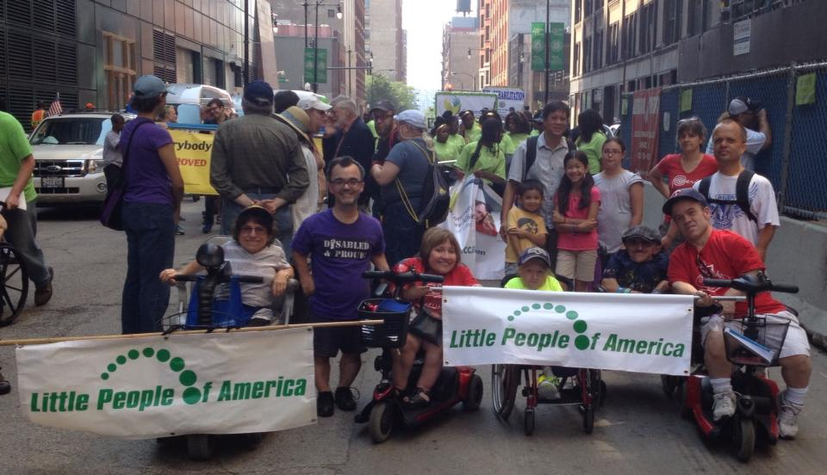
LPA President Gary Arnold is pictured in the purple shirt.

“As president of Little People of America, my goal is not only to pursue projects that will benefit the organization during my term of office, it is also to implement initiatives that will benefit the long term, ongoing health and growth of the organization.” --Gary Arnold, President, 2011-17

As the world’s foremost resource and advocate for individuals with dwarfism, LPA provides educational scholarships, medical knowledge and assistance, adoption resources, social opportunities and peer support for its members. It also engages in public awareness and advocacy activities to dispel myths and stereotypes about dwarfism.

In February of 2015, we updated our strategic plan and identified six major strategic priorities for 2015-17:

- Strategic Priority 1: Serving the Membership. We are a membership organization and we value our members at all levels of their involvement; local, regional and national. We will continually find ways to enhance the membership experience through our programs, connections, and engagement
- Strategic Priority 2: Critical Agency Alignment. We will be working to revise and clarify our Policy Manual and grow Best Practices at all levels of the organization.
- Strategic Priority 3: Enhance Financial Resources. Through fundraising, promoting the value of membership and careful stewardship LPA will continue to enhance our financial strength.
- Strategic Priority 4: Improve Communication throughout all areas of the organization. LPA will be creating videos of current events as well as our history.
- Strategic Priority 5: Program Development. LPA will continue to enhance current programs and will begin a “Leadership LPA” program and teach and build our next generation of leaders.
- Strategic Priority 6: Enhance Relationship with LPA and Medical Advisory Board. LPA is very thankful for the interest, time and caring shown by our 25+ members of the Medical Advisory Board, and as such LPA will continue to be involved in medical changes as they occur across time.

History
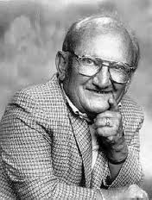
In 1957, well-known actor Billy Barty made a national public appeal for all Little People in America to join him for a gathering in Reno, Nevada. Mr. Barty and 20 other Little People joined together for a week of sharing and learning that they were not alone in facing the challenges of dwarfism. LPA was formed!
Today, LPA, the largest organization in the world devoted to people of short stature, has nearly 6,500 members and assists in the formation of related groups throughout the world. In 2007, we celebrated our 50th anniversary in Seattle. Our highest attended conference was Anaheim in 2011 with 2500+ attendees, our highest attendance to date. Our conference attendance continues to be strong, with nearly 2,300 attending our 2014 conference in San Diego, California.

Programs

“Being a part of LPA in my teen years allowed me to embrace my difference and represent the dwarfism community in many different capacities. LPA helped tremendously in my transition from high school to college, not only through generous scholarships, but instilling an attitude that anything is possible.” --Danielle Frank

National Conference - The LPA annual national conference attracts as many as 2,500 people for a week full of fun, sharing, learning and peer support. Our conferences occur in a different U.S. city each July. The conference includes more than 30 workshops, daily parent meetings, teen events, children's activities, fashion and talent shows, a celebration banquet, athletic events through our sister organization, the Dwarf Athletic Association of America (DAAA), and nightly dancing. A free medical clinic is offered by world renowned specialists in dwarfism. Workshops cover a variety of topics, such as disability rights, advocacy, medical issues, sibling concerns, adaptive living, and employment. It is important for everyone – parents, children, adults with dwarfism – to know that they are not alone.
LPA Today – Our quarterly magazine for members has long been a membership staple. Many members live in parts of the country where there are very few other people with dwarfism and do not have the ability to travel to local or national meetings. LPA Today keeps our membership informed about a variety of dwarfism issues. It also shares stories of success and accomplishments. It highlights our many events with pictures that embrace our physical difference. It allows people with dwarfism to see themselves reflected in others.
lpaonline.org –This highly regarded, comprehensive tool receives more than 1,000 hits a month from members and nonmembers, people of short and average stature, the media, researchers, medical professionals, and others. In 2013, the site underwent an extensive revision to better serve the needs of the membership as well as provide additional awareness and education about the dwarfism community. We also offer a toll-free phone line, 1-888-LPA-2001.
Medical Advisory Board - Our Medical Advisory Board is comprised of 25 respected geneticists, genetic therapists, orthopedists, neurologists, and researchers. Our Medical Advisory Board donates their time at each annual National Conference, and may attend district conferences as well. They hold workshops and consult with patients free-of-charge. This is a vital lifeline for many of our members who do not have adequate access to specialists in dwarfism due to geographic or insurance limitations.
Scholarships - LPA also provides educational scholarships for college or vocational training, medical-assistance grants for individuals with limited insurance, assistance with adoption expenses, and travel assistance funding for first-time conference attendees.
Public Access – In 1994, LPA was approved as a member organization of the International Code Council (ICC) / American National Standards Institute (ANSI) A117.1 Committee on Accessible and Usable Buildings and Facilities. We actively participated in revisions to the 1998 and 2003 editions of the Standard. Our advocacy resulted in the height of key elements in new and altered buildings being lowered from 54 to 48 inches, the development of new technology in elevators for buttons that cannot be lowered, and requirements that make it possible for people with dwarfism to wash their hands with soap and water in public bathrooms.

Our Board, Staff and Operating Structure
During fiscal year 2012-13, LPA accomplished a major goal: passage of a new board structure.
In the past, LPA’s board of directors had included 20 members – a six-member executive committee and 14 district directors. Right before our 2013 National Conference in Washington, D.C., LPA’s membership approved a new set of organizational bylaws, which created a new board structure which calls for an 11 member board of directors. These positions – and those serving from 2014-17 – are:

President Gary Arnold
Senior Vice President April Brazier
Finance Director Danh Trang
Membership Director Mark Povinelli
Programs Director Jon North
Public Relations Director Leah Smith
Advocacy Director Michelle Kraus
Fund Development Director Eileen Norman
Eastern Regional At-Large Representative Joe Zrinski
Central Regional At-Large Representative Becky Roach
Western Regional At-Large Representative Angie Giuffre

The new structure allows each district director to focus exclusively on serving their respective chapters while maintaining close communication with the president and other district directors through a Council of Directors, which meets at least twice a year. It also created new positions in the critical areas of advocacy and fund development. The primary reason our leadership felt this restructure was key – and the reason our members were in support of the change – was that the new structure created a more effective means to serve our membership on the local, regional and national levels.
Among its 13 districts, LPA has 70 chapters that handle local events, support needs and information. In addition, LPA has an active group of appointed national committee chairs who run our various programs, including Adoption, Advocacy, Dwarf Artists Coalition, Fundraising, Historian, Information Technology, International, Medical Resource Center, National Conference Review, Outreach, Parents, Teens, and Seniors.
Our board members live across the country and communicate via electronic media and teleconference calls every other month. The board meets face-to-face for two or three days during the National Conference in July and every three to four years in the winter for a mid-year meeting.
As of February 2015, LPA was staffed by three part-time staff members. Joanna Campbell has served as part-time executive director since 2006. The average-height mom of a college-age member, Joanna has volunteered for LPA since her daughter was a toddler. She served as LPA’s first average-height District Director from 1996-1999. Joanna has also been Chapter President, 1998 Los Angeles National Conference Chair, District Parent Chair and is the author of the booklet LPA provides all new families, “It’s a Whole New View: A Beginner’s Guide to Raising a Child with Dwarfism.” Joanna is responsible for program development and implementation consistent with our strategic plan, fundraising and organizational development goals.
In addition, LPA employs two part-time administrative assistants. Sandy Taylor and Vicky Schulte staff the office on a daily basis and answer phones, respond to membership and public inquiries and requests via phone or email, and handle incoming and outgoing print mail. Additionally, Vicky coordinates a variety of membership activities, and Sandy manages LPA Today advertising, school presentations, and preparing and emailing LPA’s monthly message. All three staff members manage LPA’s Facebook page and provide support to district and chapter officers as well.

Financial Summary
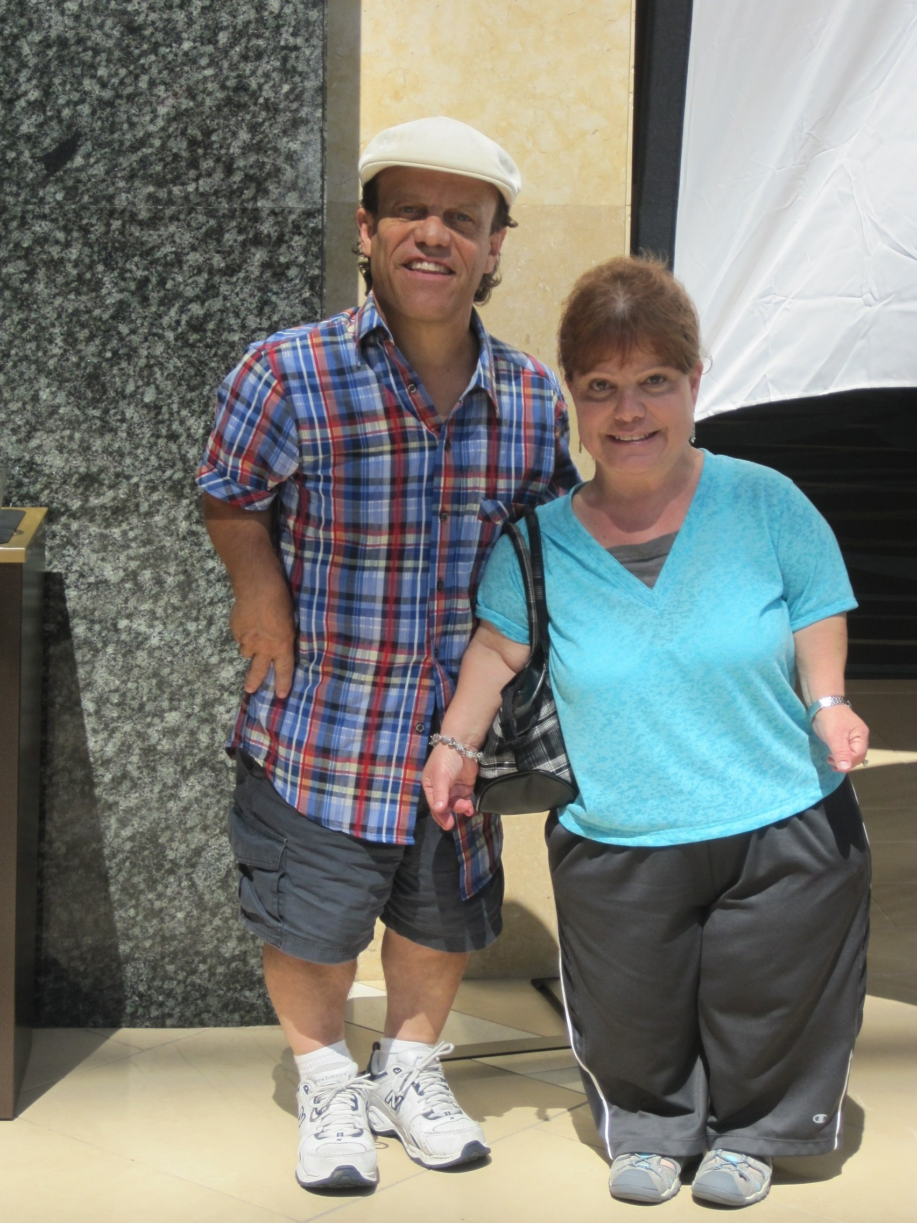
“We always try and designate our gifts to scholarships—education is so key. The dollars we give, however, are nothing compared to what we get back from LPA. Being part of LPA gives us an opportunity to connect with people who are just like us. In fact, attending the annual conference gives us the strength to go on for the rest of the year.”
--Joe and Kathy Gieb

The funding required to operate Little People of America comes from four major sources: contributions, membership dues, national conference income and other income (including investments and transfer of assets from restricted accounts). A summary of our 2012-13 financials (based on the IRS form 990) is provided below:
Category | 2012-13 Actuals
Income
Contributions | $132,745
Membership Dues | 58,071
Conference Fees | 226,783
Other income (investment income, transfer of assets from restricted accounts, etc.) | 108,645
Total Income | $526,244
Expense
Programs and Services
Conference | $202,263
Scholarships for education, adoption, medical assistance and conference attendance | 53,150
LPA Today and other printing | 50,567
Other expenses related to delivery of programs and services (staffing, travel, insurance, etc.) | 102,820
Sub-Total: Programs and Services | $408,800
Management, Fundraising and General
Salaries and related | $ 28,862
Professional fees | 16,016
Advertising and promotion | 1,208
Rent | 13,125
Office expenses | 5,422
Information technology | 15,135
Other expenses | 284
Sub-Total: Management, Fundraising and General | $ 80,052
Total Expense | $488,852
Net Income | $ 37,392
As of September 30, 2013, LPA held assets of just over $1 million. Most of these funds are held in restricted and/or endowment accounts. It is also important to note that, during 2012-13, LPA allocated 84% of its budget to programs and services – significantly higher than the minimum of 65% recommended by the Better Business Bureau.

Why Should You Support LPA?

“LPA has long been an important part of my life. When I was in kindergarten, I was being picked on and teased, and was having a difficult time adjusting to school. So, my parents sought out help from our local LPA chapter. One of the couples involved in our chapter, Al and Harriet Stickney, volunteered to do an assembly about dwarfism for my entire school. It helped the other students understand my physical difference, and also gave me the confidence I needed to succeed. Things really turned around from there.”

“I kept in touch with my kindergarten teacher through the years, and when I was in high school, she contacted me to let me know she had a girl with achondroplasia in her current class. Cassandra was

experiencing the same challenges I had. Fortunately my dad had videotaped my assembly, so I was able to review what the Stickneys had done 11 years earlier and base my assembly for Cassandra on theirs. It was even held in the same cafeteria with several of the same teachers also in attendance. The assembly also broke the ice for Cassandra, and provided me with the realization that I had ‘come full circle’ in benefiting from, then helping others through, my involvement in LPA.” --Danh Trang
Since 2006, LPA has experienced dramatic growth in its membership, programs and services. With the guidance of our new strategic plan, LPA will continue to grow and develop as we continue to provide important programs and services to our members.
Each of our initiatives requires charitable support from our members and friends. During 2014-15, LPA must raise $95,000 through grants and private contributions to help implement its programs and accomplish its goals.
Every dollar contributed to LPA, Inc. helps move the organization to the next level. Here are some examples of what you gift can do:
- A contribution of $50 will sponsor one low-income family for membership.
- A contribution of $100 will provide conference registration fees for a new family or member to attend a National Conference.
- A contribution of $250 will reach five schools with our Community Outreach program and materials.
- A contribution of $500 will sponsor one low-income family for a life membership.
- A contribution of $750 will assist one family through the adoption process.
- A contribution of $1,000 will create a one-time named scholarship for college or trade school.
- A contribution of $1,500 will cover the cost of sending an LPA representative to participate in a week long meeting of the ICC/ANSI A117.1 Committee on Accessible Buildings and Facilities.
- A contribution of $2,000 will cover the cost of sending a family of four to an LPA national conference to benefit from the free medical clinic, workshops, parent meetings, and peer support.
- A contribution of $4,000 will cover the cost of LPA exhibiting at a medical professional conference.
- A contribution of $5,000 will cover the cost of reprinting the new parent publication, “It’s a Whole New View: A Beginner’s Guide to Raising a Child with Dwarfism.”
- A contribution of $6,000 will cover the cost of publishing one issue of LPA Today, our quarterly membership magazine.
Donors who contribute at least $50 are also recognized as members of our $50 for 50 More Years Campaign.

Getting Involved


“One of the greatest things LPA has given us is the knowledge of other members. They were available to chat on-line and by phone. They were a wonderful resource to us, parents who were experiencing the unknown.”
--Alex and Jeff Bray

For some members, receiving our quarterly magazine (LPA Today) is a sufficient connection to our community. But many other opportunities are available to those who would like to get involved. There are 70 local chapters which meet monthly or quarterly and 13 districts that meet each spring and fall. The Executive Committee, District Directors, and committee chair positions are held by individuals with a passion for LPA and its future. We welcome involvement by members of all ages and heights – average or short-statured. For additional information about membership or volunteering, please visit www.lpaonline.org.

Giving Form

Yes, I/we would like to help LPA provide support and information to people of short stature and their families.

_____Mr. _____Mr. & Mrs. _____Ms. _____Mrs. _____ Other: ____________

____ We wish to remain anonymous

Name:_______________________________________________________________

Address:_____________________________________________________________

City:________________________ State: __________ Zip:________________

Phone: ______________________________________E-mail: _________________

Enclosed is a donation of [ ] $50 [ ] $100 [ ] $150 [ ] $250

[ ] $500 [ ] $750 [ ] $1,000 [ ] $2,500 [ ] $5,000 [ ] $6,000

[ ] Other: $___________
Please note that a gift of $50 or more qualifies you for recognition in LPA’s $50 for 50 More Years giving campaign.

Please make checks payable to Little People of America or visit www.lpaonline.org to make a donation by credit card.

Please mail form and donation to:

Little People of America
250 El Camino Real--Suite 211
Tustin, CA 92780

Toll-free: (888) LPA-2001
Direct: (714) 368-3689
Executive Director Direct: (714) 862-4247
Fax: (714) 368-3367
Web site: www.lpaonline.org

